PROPOSAL OMG SO EXCITING  
Homelessness “Game”

1. Problem/Task - Katie and Hana
   1. Homelessness awareness
   2. Hana saw it in Ethiopia and everyone else (Katie, Ana, Darya, Kelly) see it in their cities
2. Solution - Kelly
   1. How are we solving the problem? Engaging app to raise awareness for the conditions under which homeless live
   2. Why is it interesting? Most awareness sites are “boring” - ours will be engaging. We also have kelly (very unique)
3. Implementation - Ana
   1. We are using Xcode via the app store
   2. We chose this because it’s cool and seems easier to use. We also made an app as opposed to a website because they seem more accessible
   3. TBD
4. Monetization - Darya
   1. Sponsors (once we become a huge well known company, other bigger companies - like facebook (wink wink) - will obviously want to sponsor us because we are amazing and also it looks good cuz it’s a humanitarian project

We’d be non-profit, so no add selling. We’d be paying for it ourselves until facebook realizes what it’s missing

* 1. n/a

<https://hackernoon.com/how-to-make-a-vr-app-with-zero-experience-927438e2dede#.18nuijx9z>

<https://www.youtube.com/watch?v=8_DVV2RPwWw>

<https://developer.apple.com/library/ios/documentation/UIKit/Reference/UINavigationController_Class/index.html>

[**https://www.amharicdictionary.com/index.aspx?EnglishText=poor&SearchEnglish=Search&AmharicText=**](https://www.amharicdictionary.com/index.aspx?EnglishText=poor&SearchEnglish=Search&AmharicText=)

**How to switch the different images to make them “walk”** 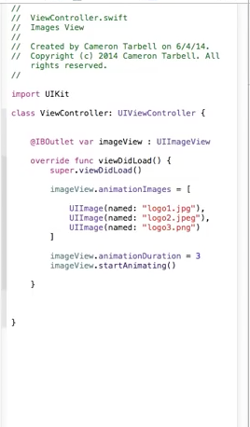

[**https://www.youtube.com/watch?v=lXTTgBQuw8M&index=16&list=PL3MWPU0RhJzHSHn1P1zZ0p1dcUKsppiya**](https://www.youtube.com/watch?v=lXTTgBQuw8M&index=16&list=PL3MWPU0RhJzHSHn1P1zZ0p1dcUKsppiya)

[**https://gyazo.com/9576db723f1f2774105a3b9d826868c5**](https://gyazo.com/9576db723f1f2774105a3b9d826868c5)

[**https://gyazo.com/31312f19dd001996e732dbaafe1c3bd8**](https://gyazo.com/31312f19dd001996e732dbaafe1c3bd8)

**how to makes it move to a location for a certain amount of time**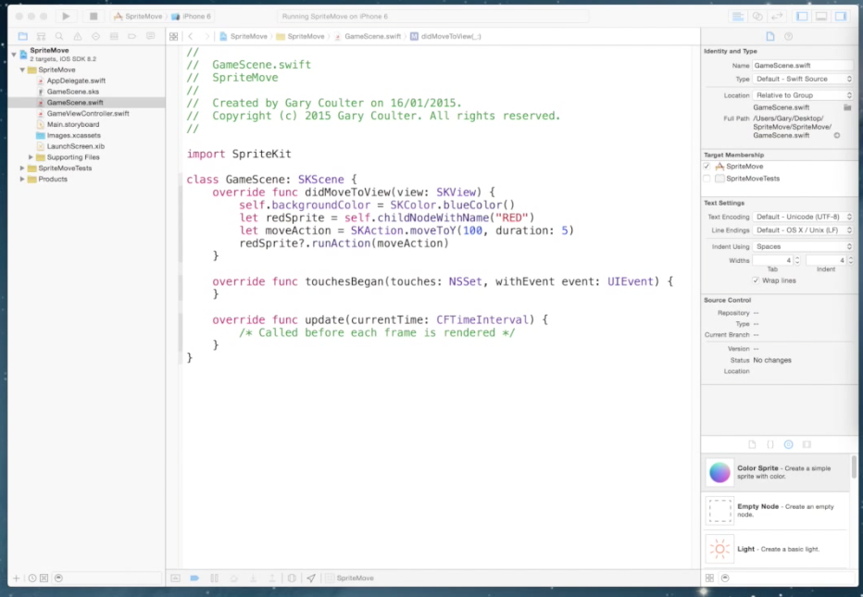

[**https://www.youtube.com/watch?v=jb4oW5o_S8w**](https://www.youtube.com/watch?v=jb4oW5o_S8w)

**How to switch data from one screen to another**

[**https://www.youtube.com/watch?v=guSYMPaXLaw**](https://www.youtube.com/watch?v=guSYMPaXLaw)